**How to find all files containing specific text in Linux – TecAdmin**

3-4 minutes 14/03/2017

This tutorial will teach you how to recursively search for files containing a specific string on Linux using the command line. This tutorial uses the ‘grep’ command to search for strings in files. Alternatively, you may use the [find command](https://tecadmin.net/find-all-files-containing-a-string-in-linux/) to look for files with specific content.

**A basic syntax for searching text with grep command:**

|  |  |
| --- | --- |
|  | grep -rl "search-string" /path/to/serch/dir |

The grep command offers other useful options for finding specific text in file systems.

* **-r, --recursive**: Search files recursively
* **-R, --dereference-recursive**: Search files recursively and follow symlinks
* **--include=FILE_PATTERN**: search only files that match FILE_PATTERN
* **--exclude=FILE_PATTERN**: skip files and directories matching FILE_PATTERN
* **--exclude-from=FILE**: skip files matching any file pattern from FILE
* **--exclude-dir=PATTERN**: directories that match PATTERN will be skipped.
* **-L, --files-without-match**: Print file names containing no match
* **-l, --files-with-matches**: Print string containing file names only
* **-i, --ignore-case**: ignore case of search string
* **-e, --regexp=PATTERN**: Use a pattern to search or specify multiple search strings
* **-w, --word-regexp**: force to match whole words

There are several ways to use the grep command to search text. Let’s discuss a few examples of searching a text/string in the file system.

1. **Search Single String in All Files**

The below example command will search the string “Error” in all files in /var/log directory and its sub-directories.

grep -rlw "Error" /var/log

Search specific text in all files using command line

1. **Search Multiple String in All Files**

The -e switch can also be utilized to find multiple strings. This is comparable to the egrep program. The example below will look for **“Error”** and **“Warning”** in all the files in the **/var/log** directory and its subdirectories.

grep -rlw -e "Error" -e "Warning" /var/log

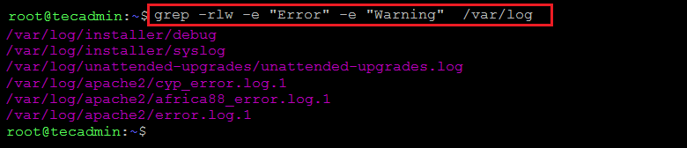Search multiple string in all files with command line

1. **Search String in Specific Files**

You can search strings in files that match the file name criteria. The following command searches for **“Error”** in files with the **.log** extension in the **/var/log** directory and its sub-directories.

grep -rlw --include="*.log" -e "Error" /var/log

1. **Exclude Some Files from Search**

You can use the --exclude option in find to exclude some files that match certain file name criteria. For example, you can exclude files with the **.txt** extension.

grep -rlw --exclude="*.txt" -e "tecadmin" /var/log

1. **Exclude Some Directories from Search**

You can also skip searching certain directories. For instance, don’t search for string files in any folder with **apache2** in its name.

grep -rlw --exclude-dir="*apache2*" -e "tecadmin" /var/log

**Conclusion**

You have learned how to search for specific text in files on the Linux file system in this tutorial.